B Tree

# Insert (Ekleme)

Insert > 1



Insert > 2

X:\Sadeceon\202006090153 - Burcubay7 (Algorithm - B-Tree & 2-3-Tree)\01_source-code\05_project\B-Tree-S\Insert\2.png

Insert > 3

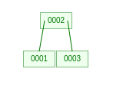

Insert > 4

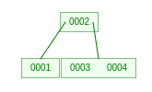

Insert > 5

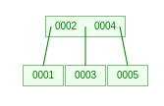

Insert > 6

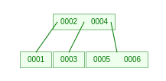

Insert > 7

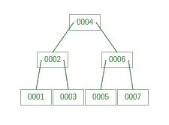

Insert > 8

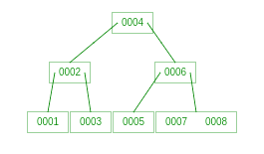

Insert > 9

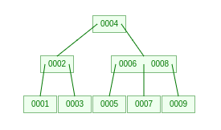

Insert > 10

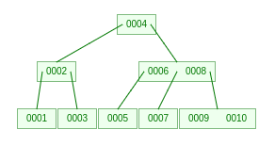

# Delete (Silme)

Delete > 9

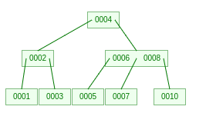

Delete > 6

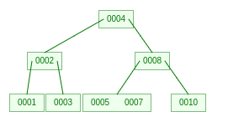

Delete > 4

